**Manual to get Windows on your laptop/ Pc**



Session 2022-2026

**Submitted By:**

Zainab Idrees 2022-CS-199

Fiza Amjad 2022-CS-172

**Supervised By:**

Mr. Numan Shafi

Department of Computer Science

**University of Engineering and Technology**

**Lahore Pakistan**

**Steps :**

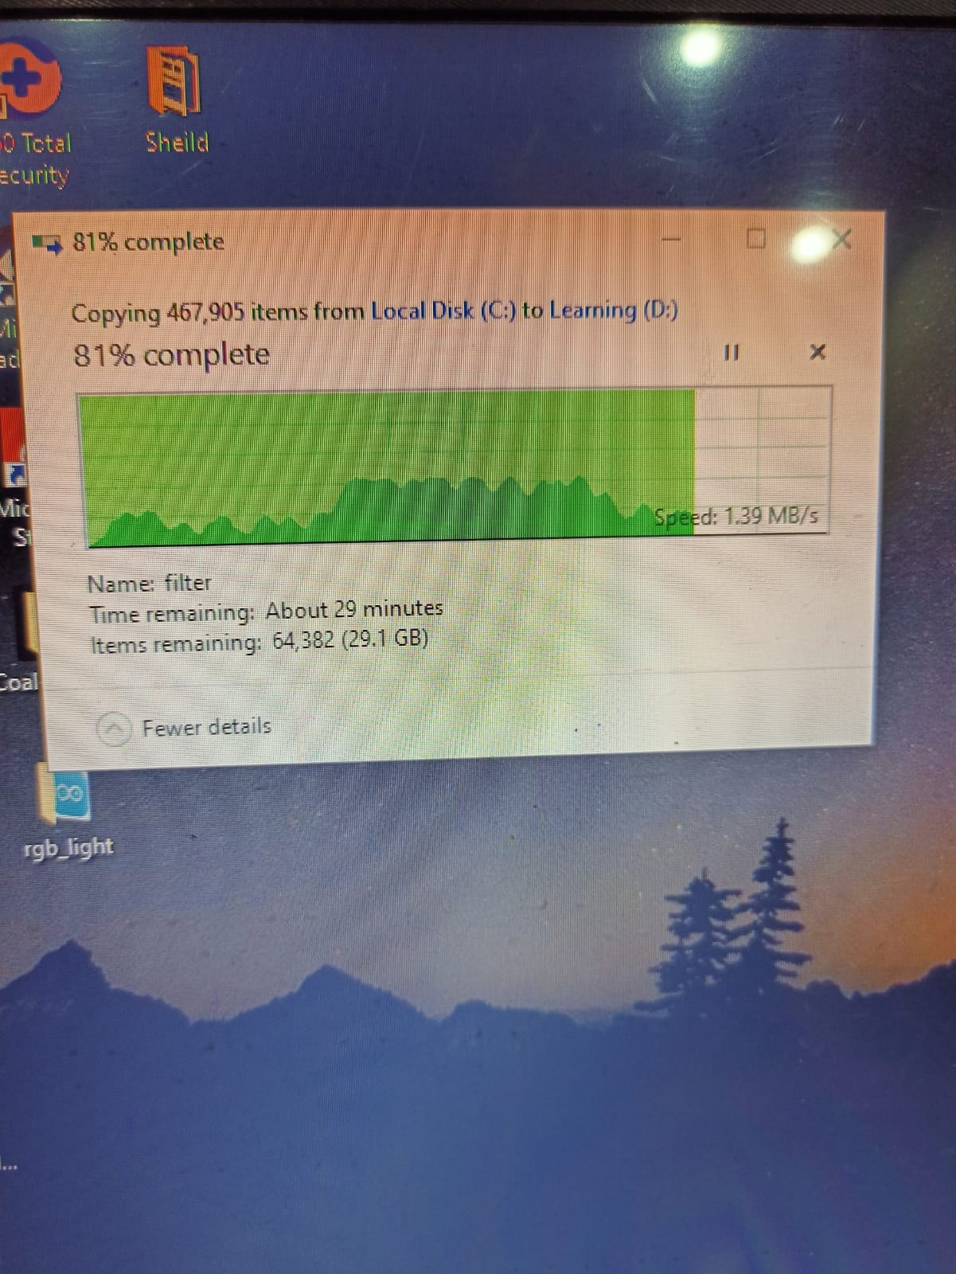

**First copy data to D drive from C drive**

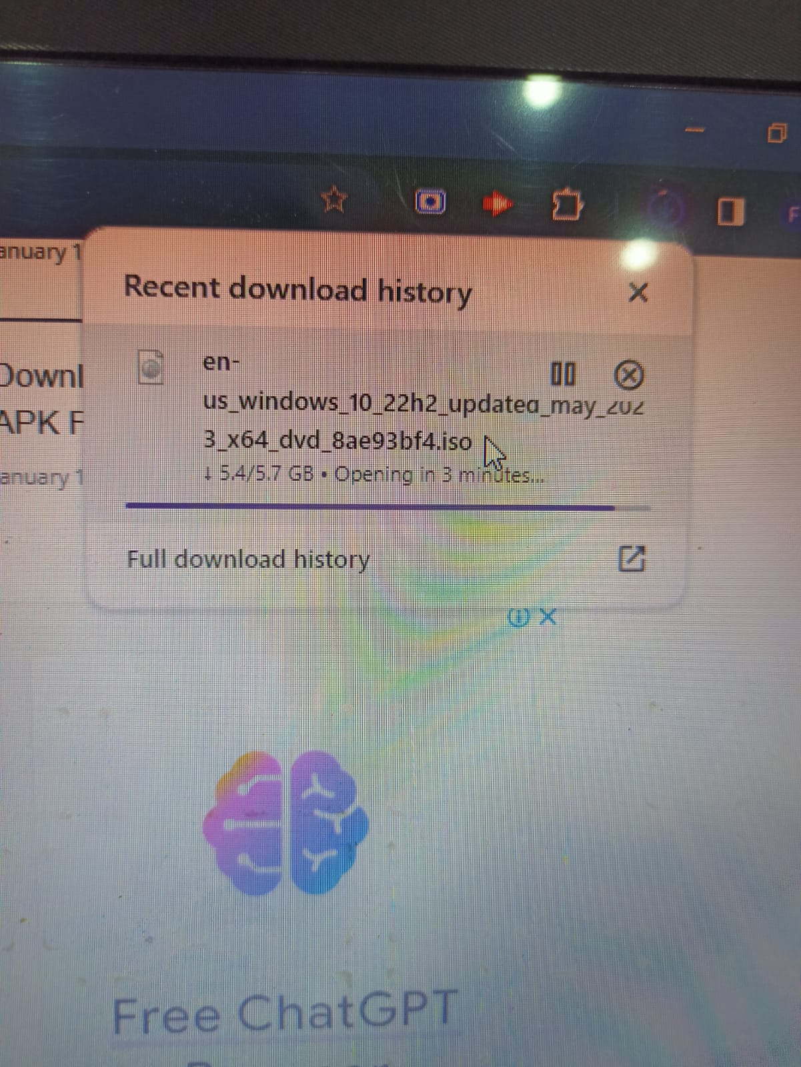

**download ISO file of windows 10**

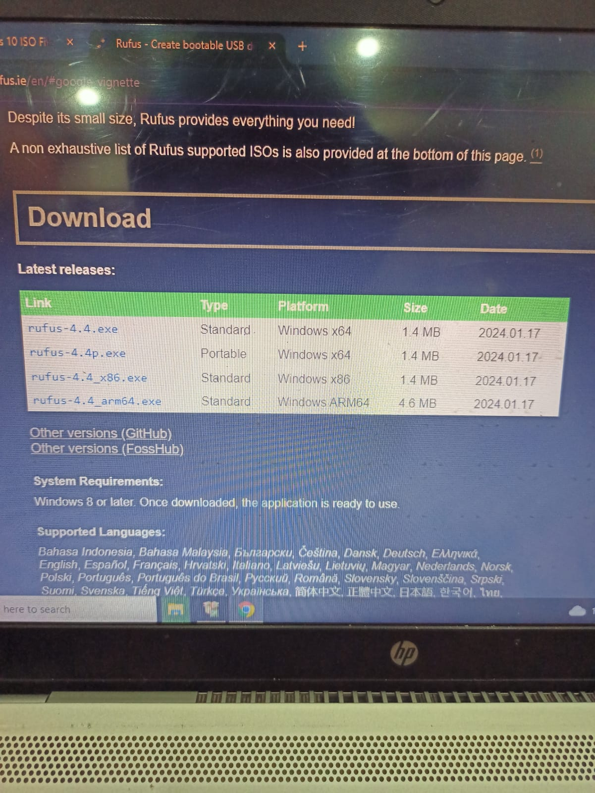

**download rufus that will make our ISO file bootable**

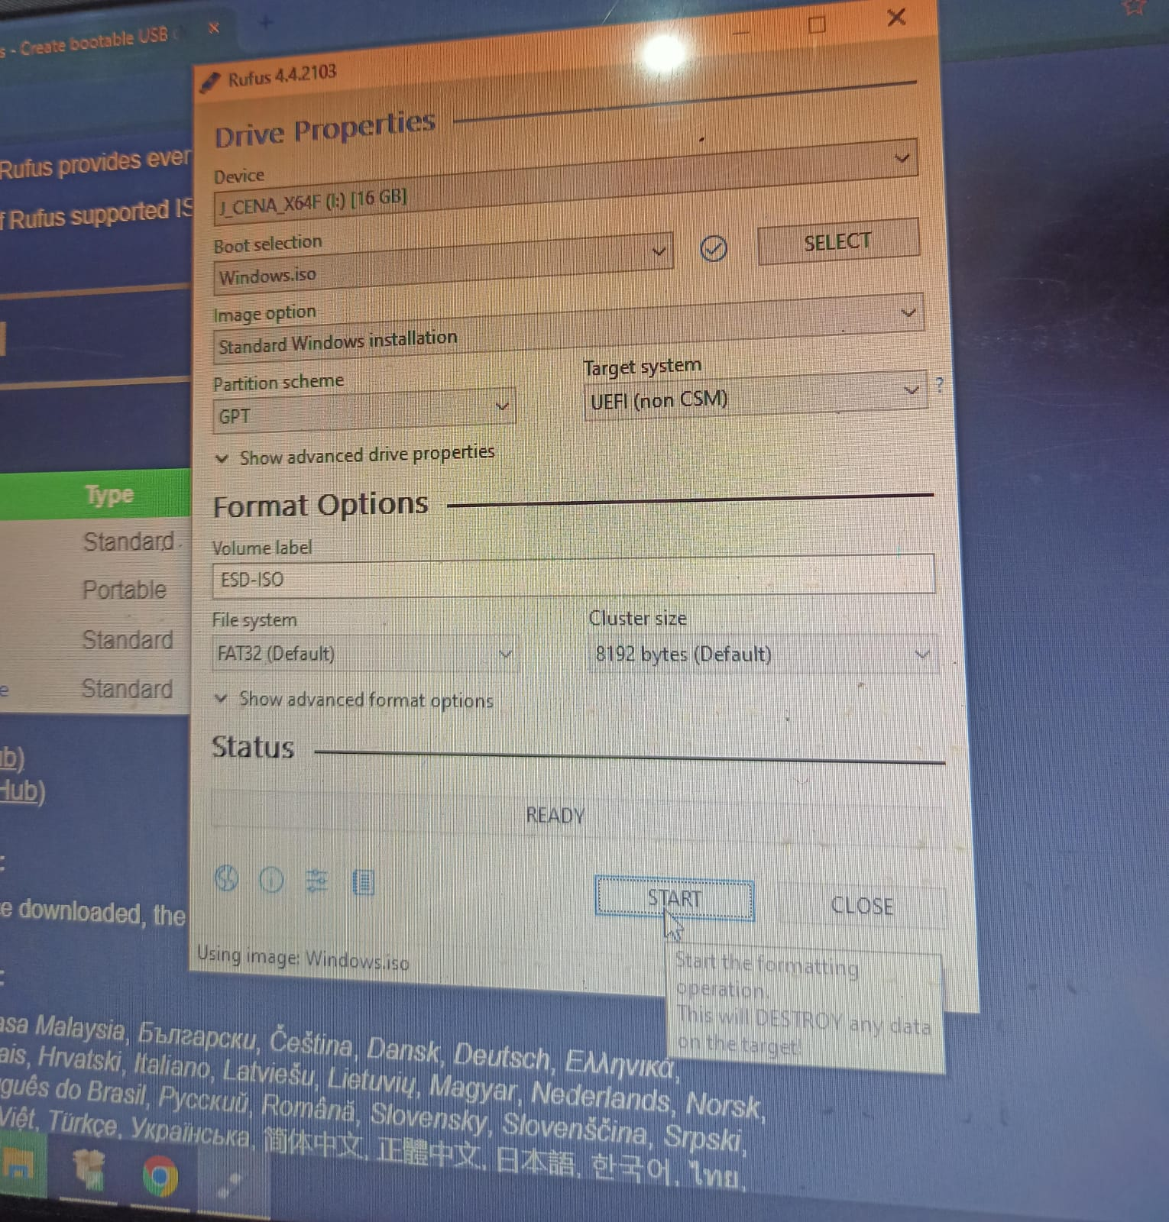

**copy that into usb**

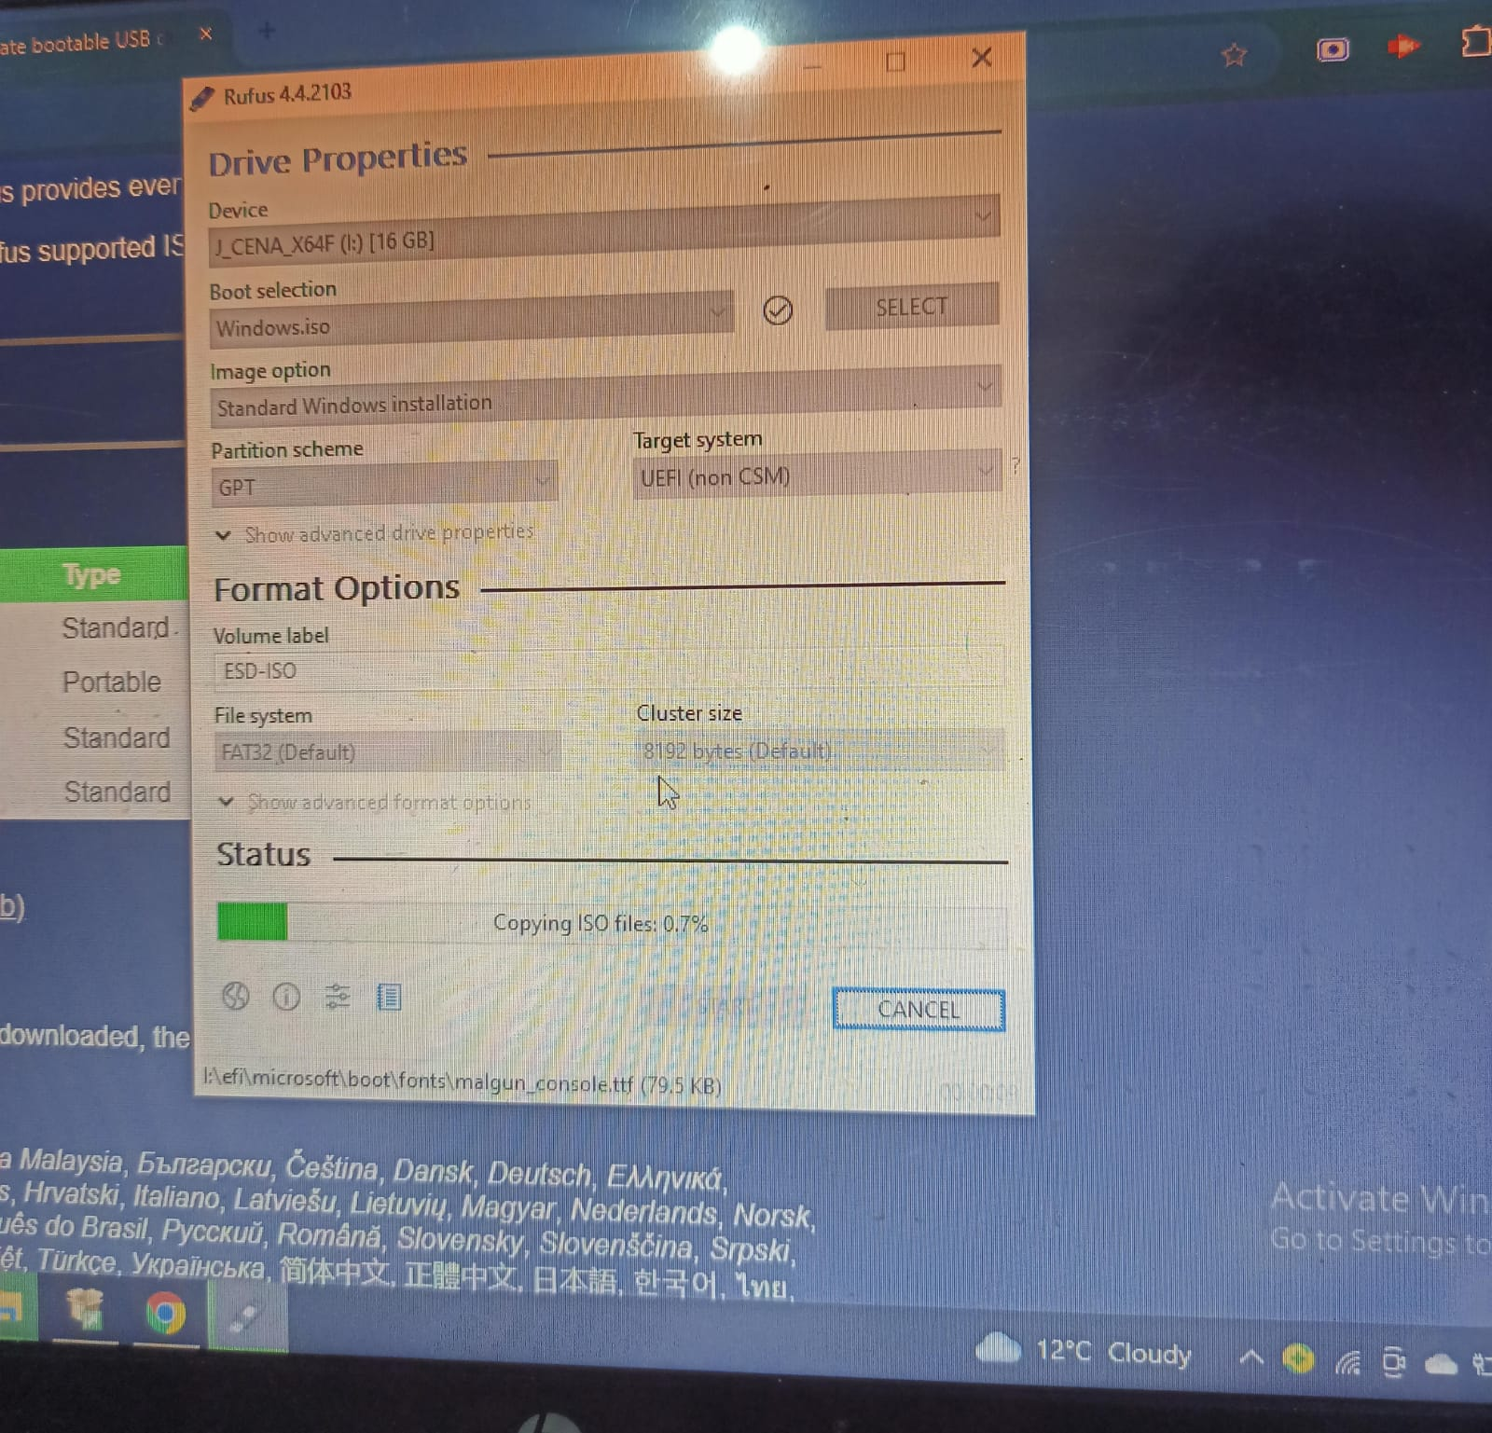

**Copying**

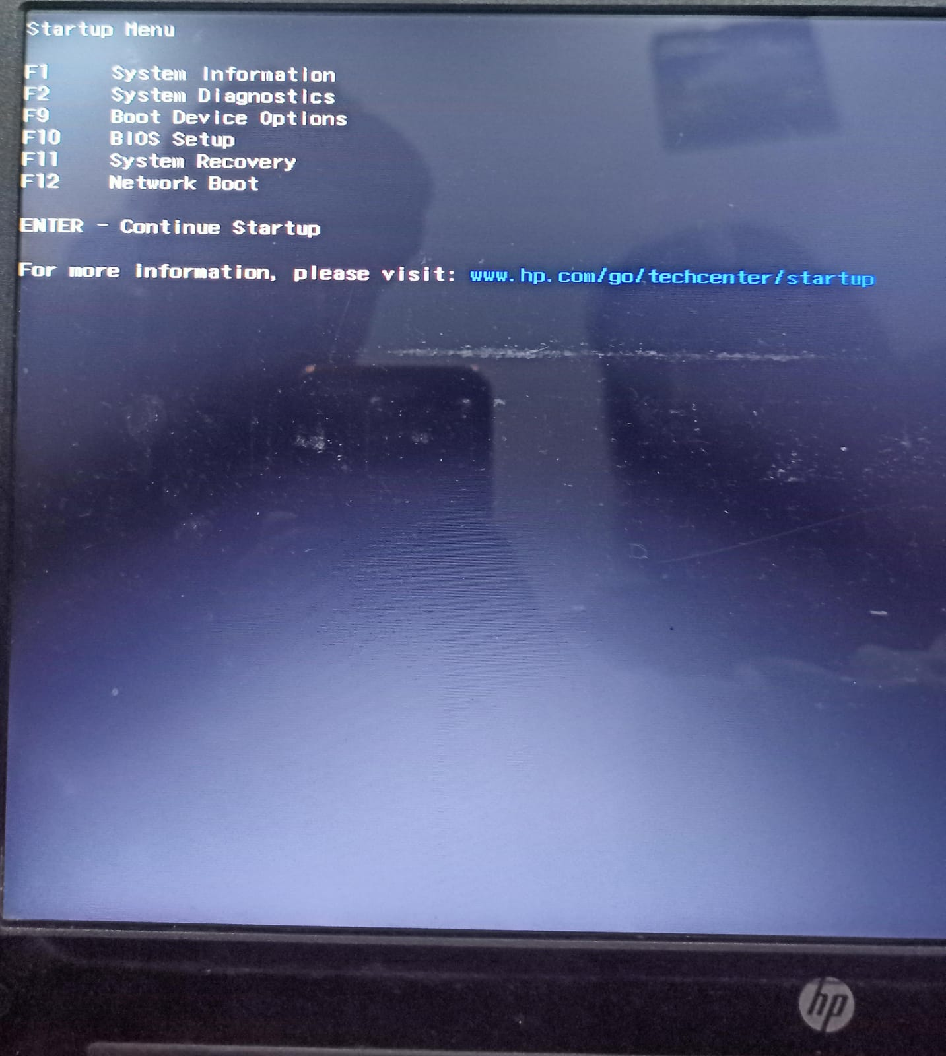

**connect the usb to your pc and select bios setup option**

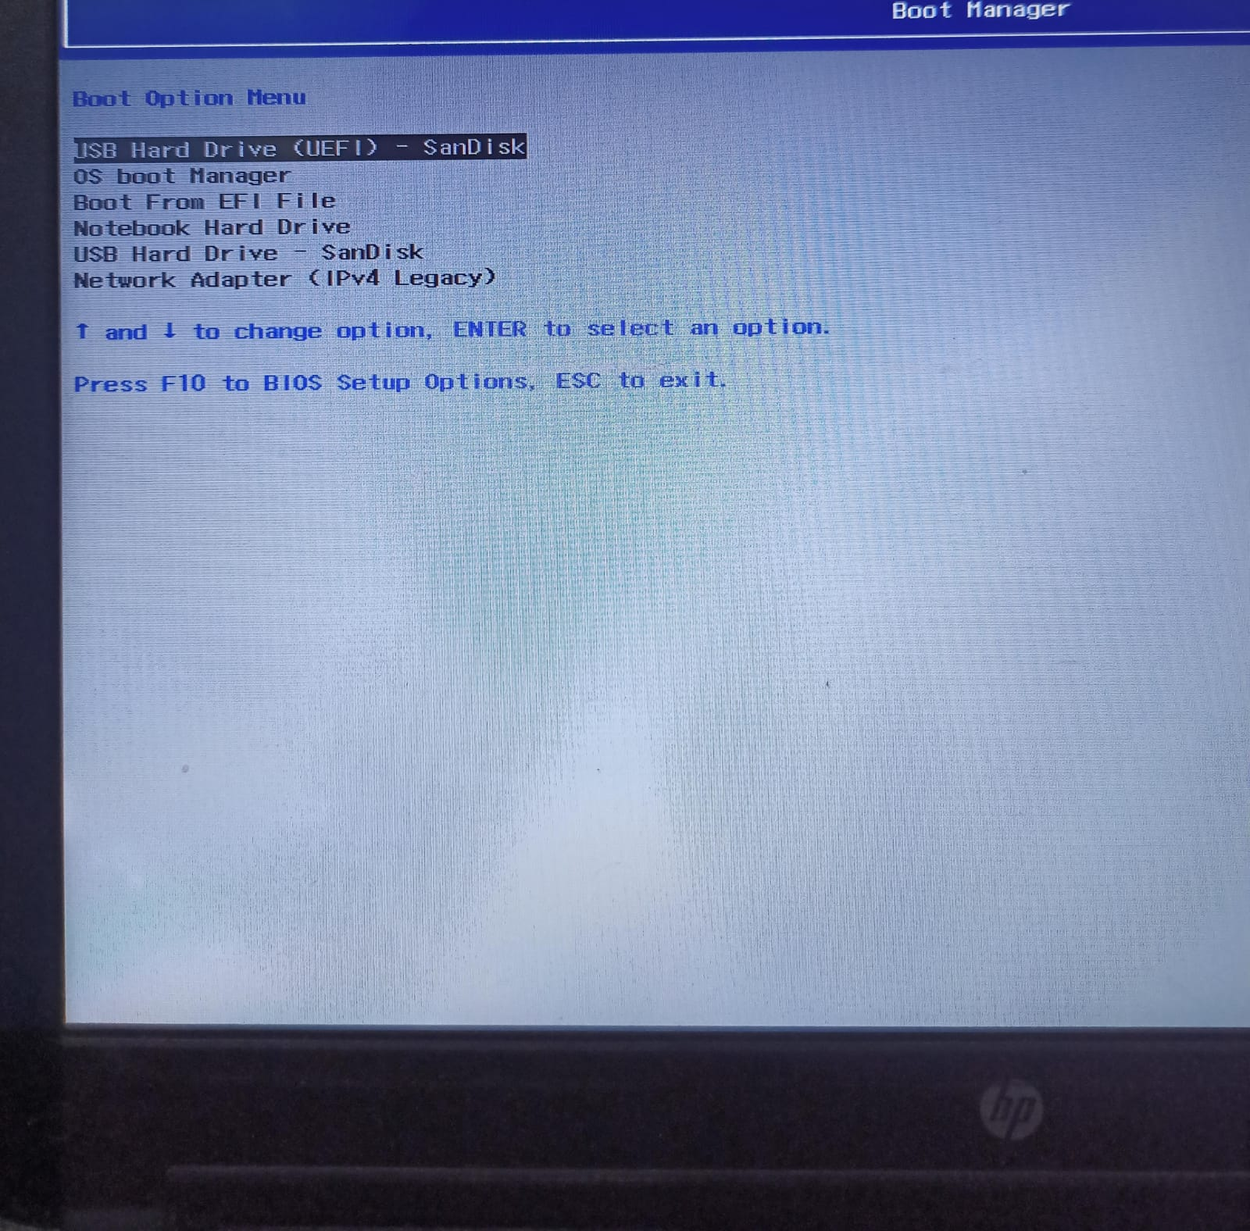

**then select ur usb that u connected**

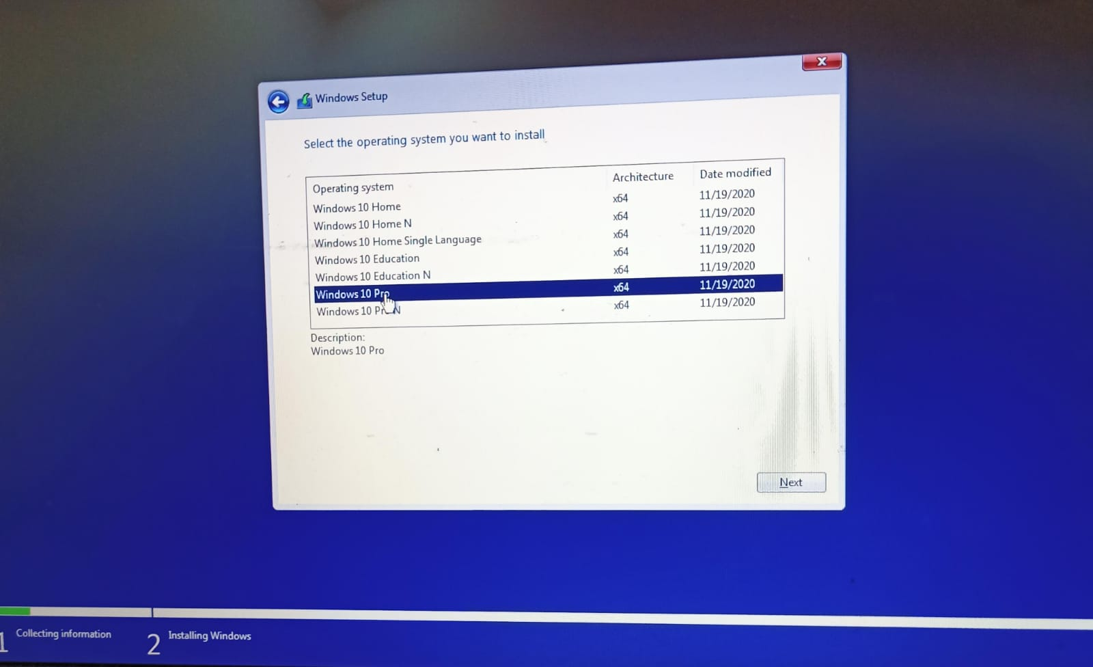

**select windows type**

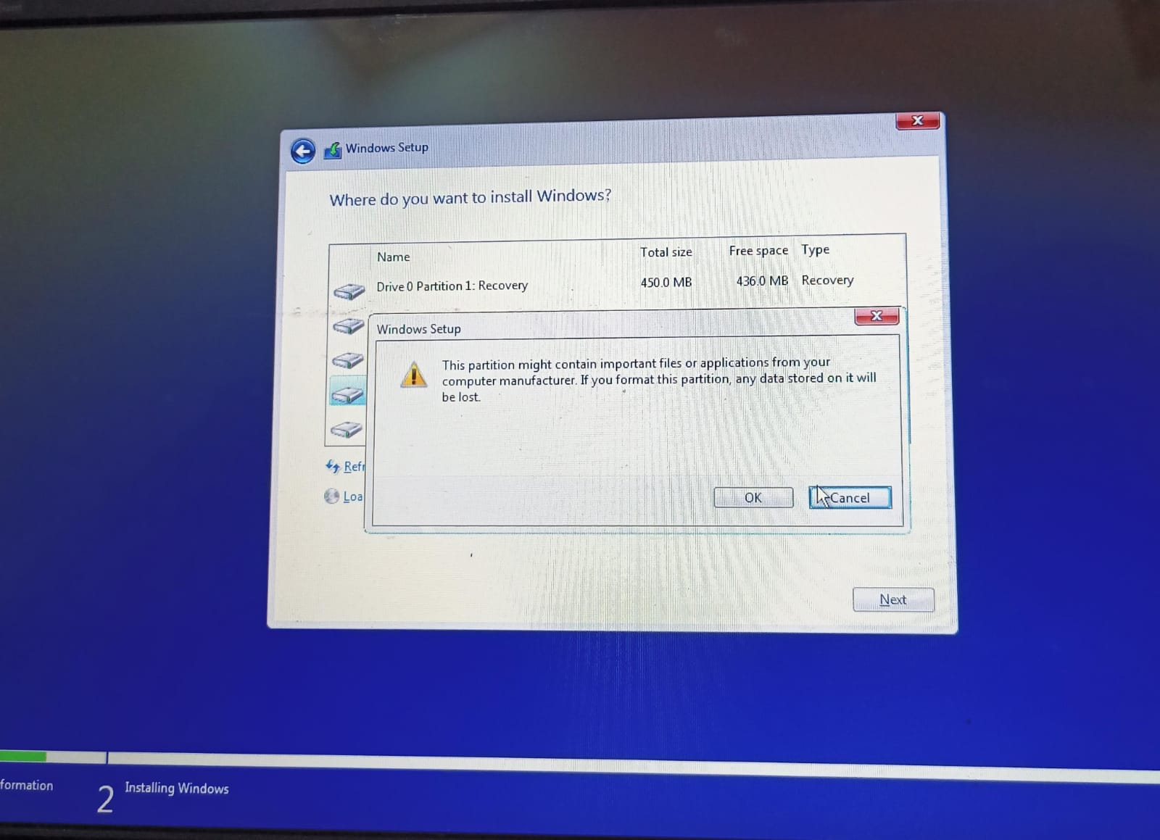

**select the partition i.e. C drive**

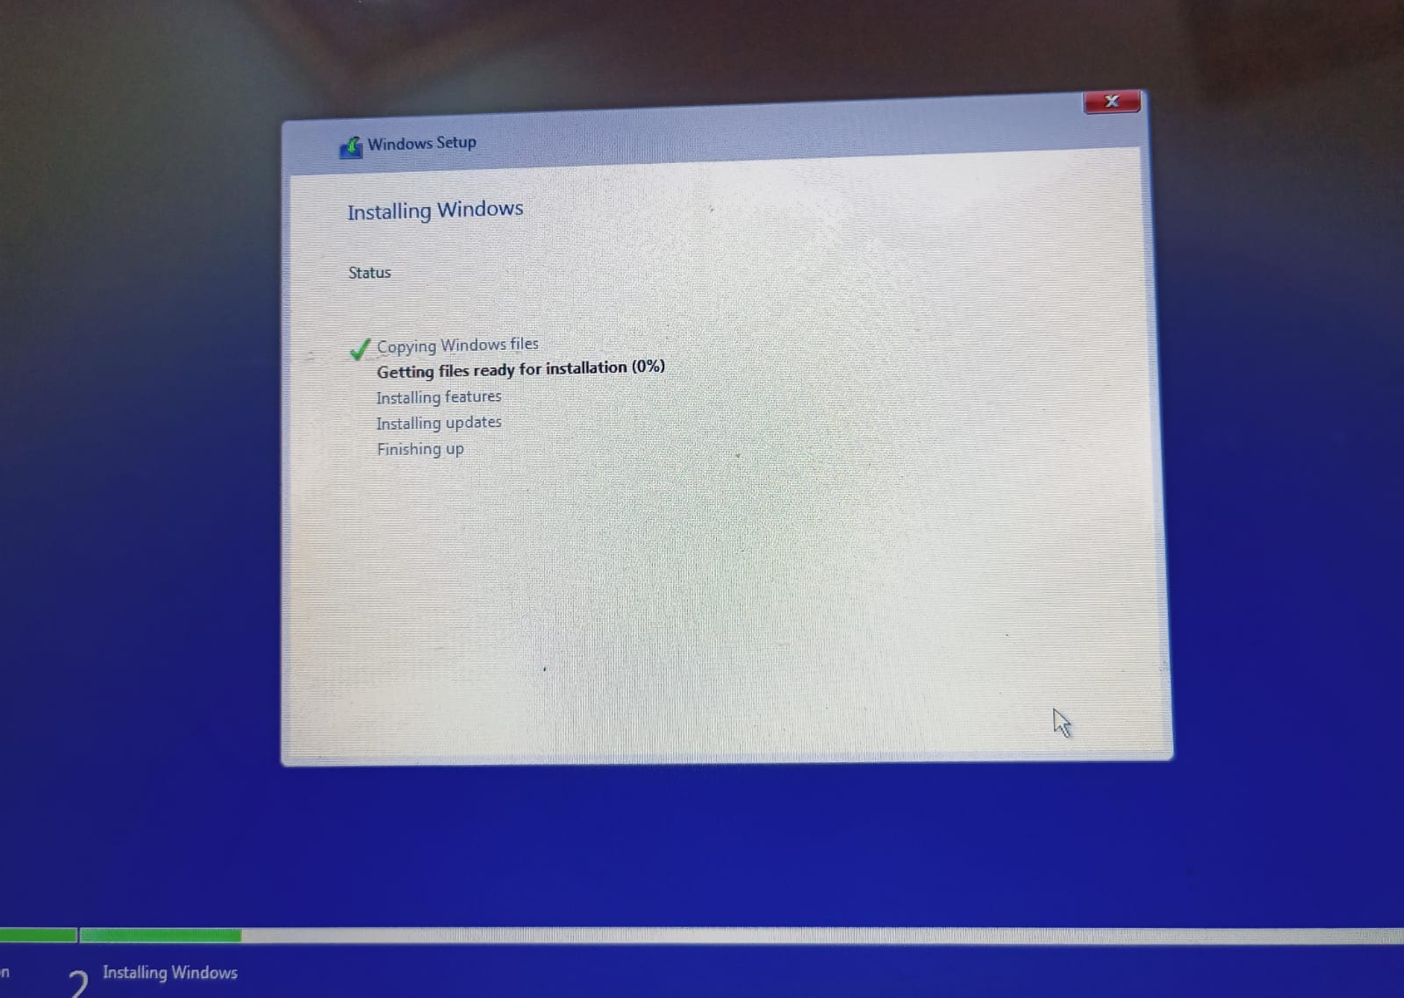

**Install the windows**

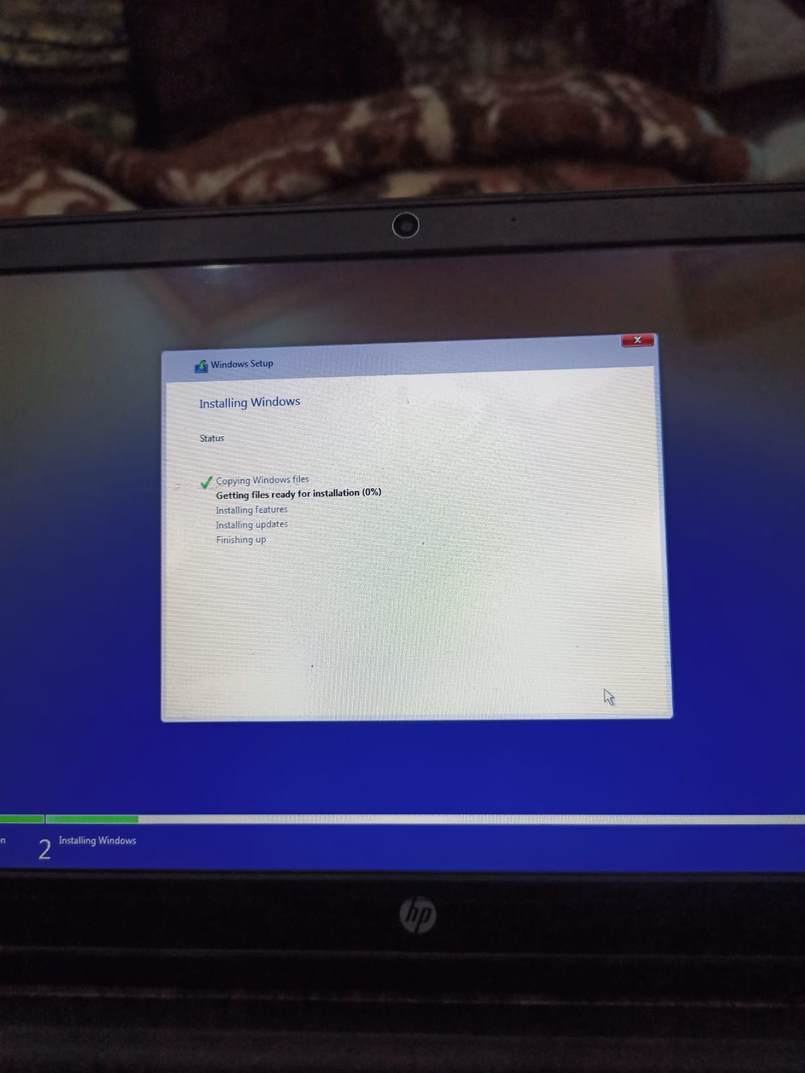

**setup your language and use it**